

COLLEGE OF TECHNOLOGY AND ENGINEERING
Information Technology Department

USER ACCEPTANCE TESTING
Test Case ID | TC-Admin-0001
Capstone Project Title: | Student Affairs and Services System
Team | LOWCODE
 | Project Leader: | Honzel Babe Chavez
 |  | Kimberly Silvano
 | Front-End Programmer: | Jhudiel Anthony Carzano
 | QA Engineer: | Mharion Jay P. Sayson
 | Technical Writer: | Francis Xavier Sagarino
Title / Business Scenario | Login with valid Email and Password
Preconditions | The user must have entered a valid registered email address and corresponding password in the login fields.
Test Data | Email: testguard@gmail.com | Password: Test@123
Steps | 1. Go to the Login page.
 | 2. Enter valid Email and Password.
 | 3. Click the “Login” button.
Expected Result | User should be redirected to the dashboard or homepage.
Actual Result (Pass/Fail) | Pass
Comments / Attachments (Screenshots, Logs) | Screenshot attached to the next page
Tester Name / Date | Mharion Jay P. Sayson / 10/15/2025
Panelist's Remarks
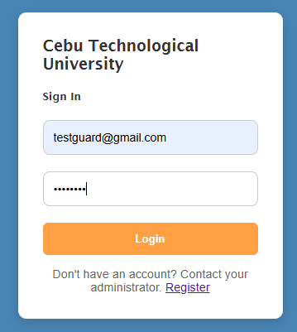
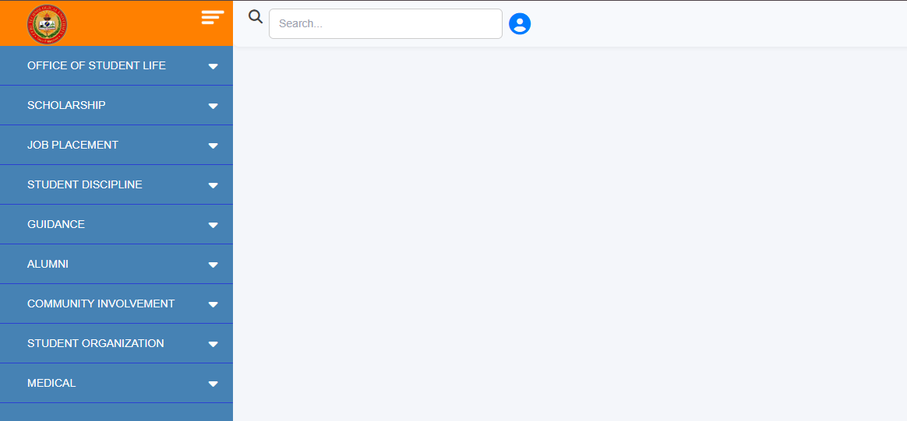


COLLEGE OF TECHNOLOGY AND ENGINEERING
Information Technology Department

USER ACCEPTANCE TESTING
Test Case ID | TC-Admin-0002
Capstone Project Title: | Student Affairs and Services System
Team | LOWCODE
 | Project Leader: | Honzel Babe Chavez
 |  | Kimberly Silvano
 | Front-End Programmer: | Jhudiel Anthony Carzano
 | QA Engineer: | Mharion Jay P. Sayson
 | Technical Writer: | Francis Xavier Sagarino
Title / Business Scenario | Verify that entering a valid student ID automatically fills in the borrower’s name and program.
Preconditions | Admin must be logged in and have access to the Equipment Tracker module. Student record must exist.
Test Data | Student Id: 7181309
Steps | 1. Navigate to Office of Student Life (Admin) → Equipment Tracker.
 | 2. Enter a valid Student ID and click Search.
 | 3. Verify that Name of Borrower and Course/Program fields are auto-filled based on student records in the database.
Expected Result | System automatically retrieves and displays the student’s name and program after entering a valid Student ID.
Actual Result (Pass/Fail) | Pass
Comments / Attachments (Screenshots, Logs) | Screenshot attached to the next page
Tester Name / Date | Mharion Jay P. Sayson / 10/15/2025
Panelist's Remarks

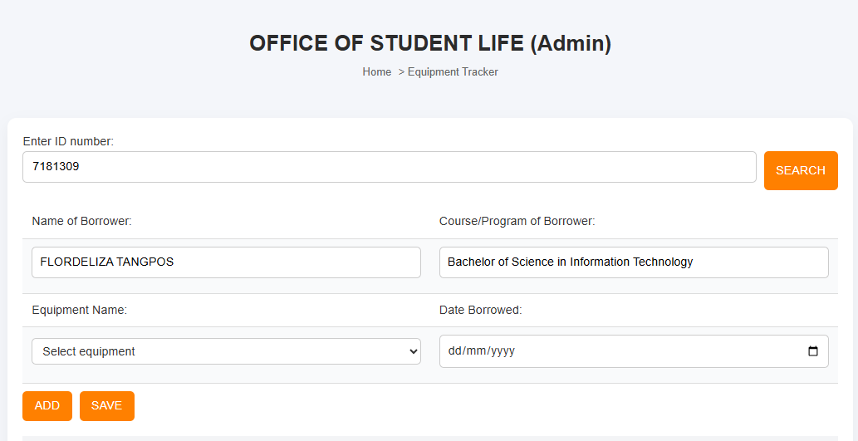
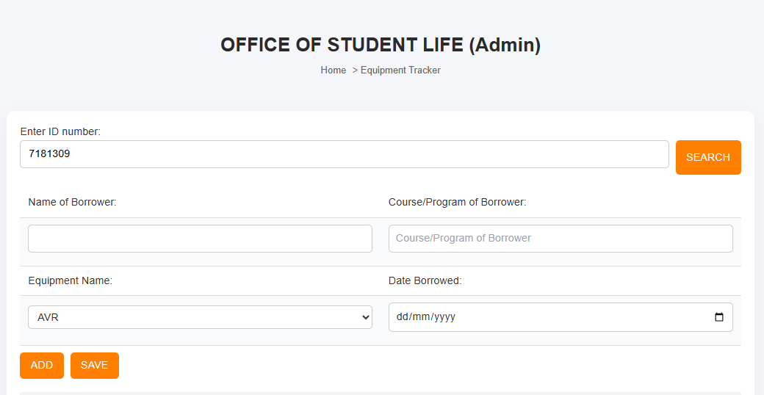



COLLEGE OF TECHNOLOGY AND ENGINEERING
Information Technology Department

USER ACCEPTANCE TESTING
Test Case ID | TC-Admin-0003
Capstone Project Title: | Student Affairs and Services System
Team | LOWCODE
 | Project Leader: |  | Honzel Babe Chavez
 |  |  | Kimberly Silvano
 | Front-End Programmer: |  | Jhudiel Anthony Carzano
 | QA Engineer: |  | Mharion Jay P. Sayson
 | Technical Writer: |  | Francis Xavier Sagarino
Title / Business Scenario | Verify that the admin can add new equipment to be listed in the dropdown for selection.
Preconditions | Admin account logged in.
Test Data | Equipment Name: Extension wire | Serial No.: 002
Steps | 1. Navigate to Add Equipment.
 | 2. Enter Equipment Name and Equipment Serial Number.
 | 3. Click Save/Add.
 | 4. Verify that the newly added equipment appears in the Equipment Name dropdown list.
Expected Result | System displays a confirmation message: “Equipment added successfully.” The new equipment then appears in the dropdown list of Equipment Name for borrowing transactions.
Actual Result (Pass/Fail) | Pass
Comments / Attachments (Screenshots, Logs) | Screenshot attached to the next page
Tester Name / Date | Mharion Jay P. Sayson / 10/15/2025
Panelist's Remarks

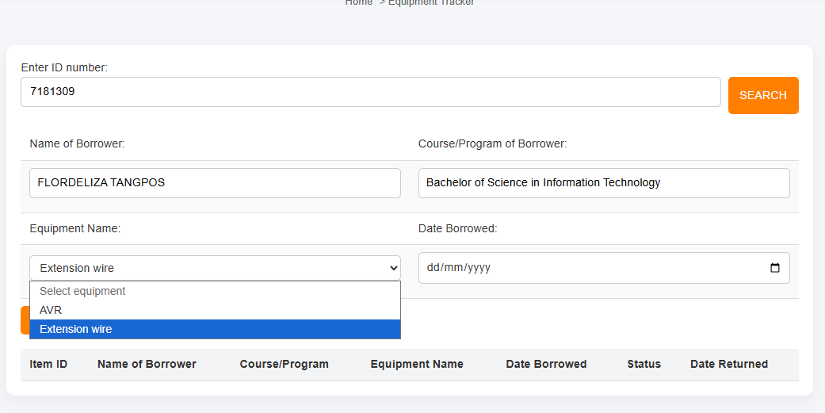
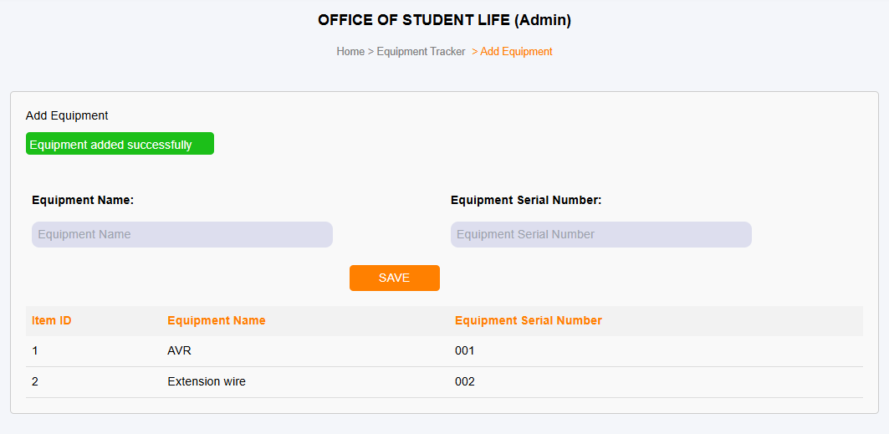
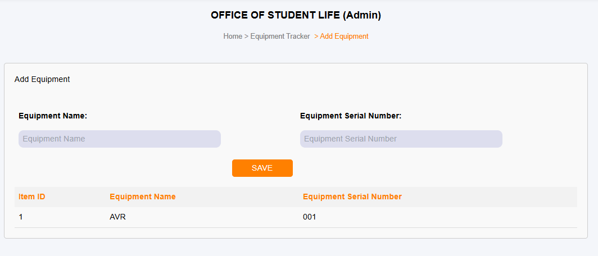



COLLEGE OF TECHNOLOGY AND ENGINEERING
Information Technology Department

USER ACCEPTANCE TESTING
Test Case ID | TC-Admin-0004
Capstone Project Title: | Student Affairs and Services System
Team | LOWCODE
 | Project Leader: | Honzel Babe Chavez
 |  | Kimberly Silvano
 | Front-End Programmer: | Jhudiel Anthony Carzano
 | QA Engineer: | Mharion Jay P. Sayson
 | Technical Writer: | Francis Xavier Sagarino
Title / Business Scenario | Verify that the admin can record borrowed equipment with a valid date.
Preconditions | Student and equipment records must exist.
Test Data | Date Borrowed: 10/20/2025
Steps | 1. After searching a student, select Equipment Name from the dropdown.
 | 2. Input Date Borrowed.
 | 3. Click Add → Save.
 | 4. Verify that the record appears in the table with the correct details.
Expected Result | A confirmation message appears: “Equipment borrowing record saved successfully.” The new record is displayed in the equipment tracker table below.
Actual Result (Pass/Fail) | Pass
Comments / Attachments (Screenshots, Logs) | Screenshot attached to the next page
Tester Name / Date | Mharion Jay P. Sayson / 10/18/2025
Panelist's Remarks

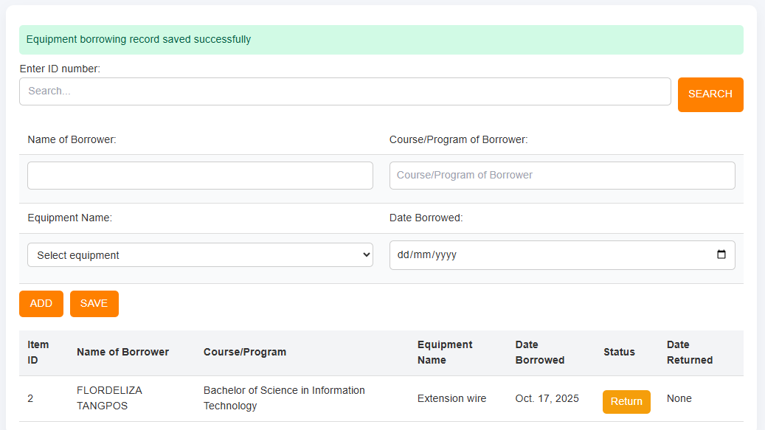
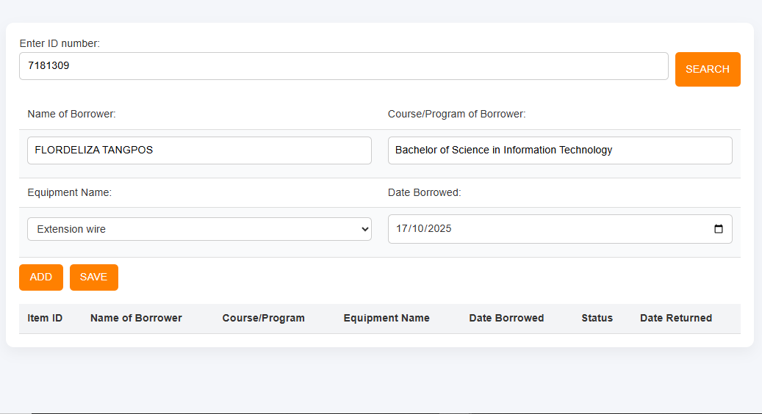



COLLEGE OF TECHNOLOGY AND ENGINEERING
Information Technology Department

USER ACCEPTANCE TESTING
Test Case ID | TC-Admin-0005
Capstone Project Title: | Student Affairs and Services System
Team | LOWCODE
 | Project Leader: |  | Honzel Babe Chavez
 |  |  | Kimberly Silvano
 | Front-End Programmer: |  | Jhudiel Anthony Carzano
 | QA Engineer: |  | Mharion Jay P. Sayson
 | Technical Writer: |  | Francis Xavier Sagarino
Title / Business Scenario | Verify marking an equipment record as returned.
Preconditions | The admin is logged in and can view the Equipment Borrowing table with at least one record having status “Borrowed.”
Test Data | Student Id: 7181309 | Equipment Name: Extension wire |  | Date Borrowed: Oct. 17, 2025
Steps | 1. Click the Return button beside a borrowed record.
 | 2. A confirmation alert appears saying “Are you sure you want to mark this item as returned?”
 | 3. Click OK to confirm.
 | 4. If OK is clicked, system updates the record.
 | 5. If Cancel is clicked, no changes are made.
Expected Result | User should be redirected to the dashboard or homepage.
Actual Result (Pass/Fail) | Pass
Comments / Attachments (Screenshots, Logs) | Screenshot attached to the next page
Tester Name / Date | Mharion Jay P. Sayson / 10/15/2025
Panelist's Remarks
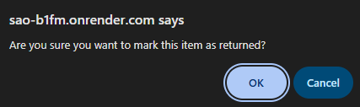
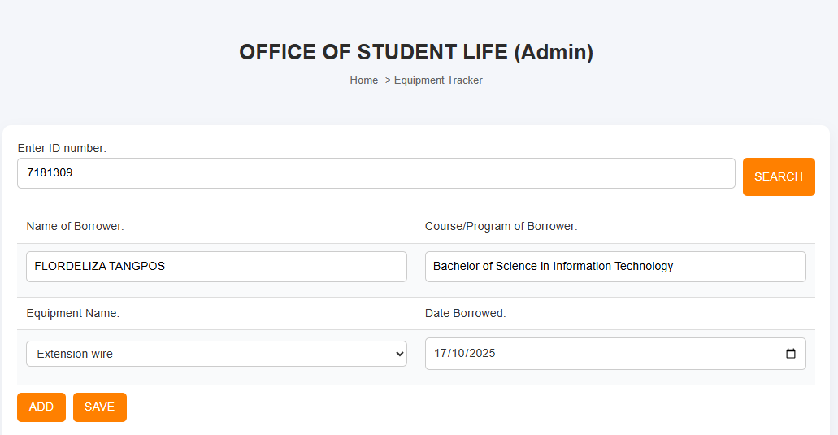



COLLEGE OF TECHNOLOGY AND ENGINEERING
Information Technology Department

USER ACCEPTANCE TESTING
Test Case ID | TC-Admin-0006
Capstone Project Title: | Student Affairs and Services System
Team | LOWCODE
 | Project Leader: |  | Honzel Babe Chavez
 |  |  | Kimberly Silvano
 | Front-End Programmer: |  | Jhudiel Anthony Carzano
 | QA Engineer: |  | Mharion Jay P. Sayson
 | Technical Writer: |  | Francis Xavier Sagarino
Title / Business Scenario | Verify that the admin can issue a Good Moral Certificate by entering the OR Number and editing the document before printing.
Preconditions | The admin is logged in with permission to access the Good Moral Certificate Issuance module and the requesting student’s information is already available in the system.
Test Data | OR Number: 0001 | School Year: 2024–2025
Steps | 1. Navigate to the Office of Student Life → Good Moral Certificate Issuance page.
 | 2. Locate the student record requesting a Good Moral Certificate.
 | 3. Enter the OR Number (e.g., 0932) in the provided input field and click the Print button.
 | 4. Verify that the system redirects to a new page displaying the Good Moral Certificate and add or edit the School Year field as required.
 | 5. Click the Print Certificate button at the bottom of the page.
Expected Result | The system redirects to the certificate editing page where the admin can add the school year, and upon clicking print, the Good Moral Certificate is generated and printed with accurate details.
Actual Result (Pass/Fail) | Pass
Comments / Attachments (Screenshots, Logs) | Screenshot attached to the next page
Tester Name / Date | Mharion Jay P. Sayson / 10/15/2025
Panelist's Remarks

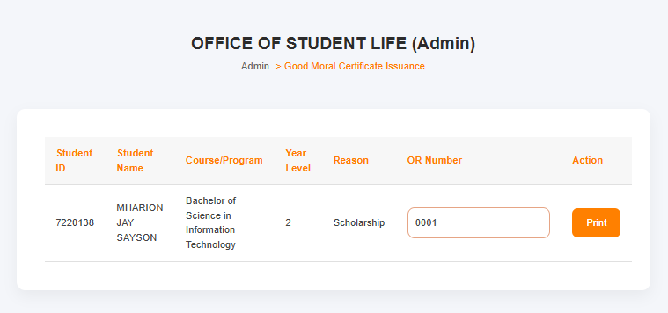
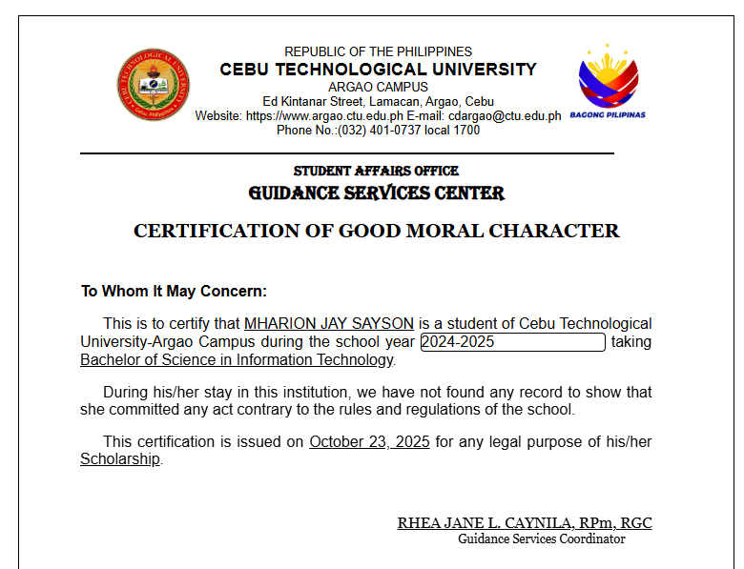
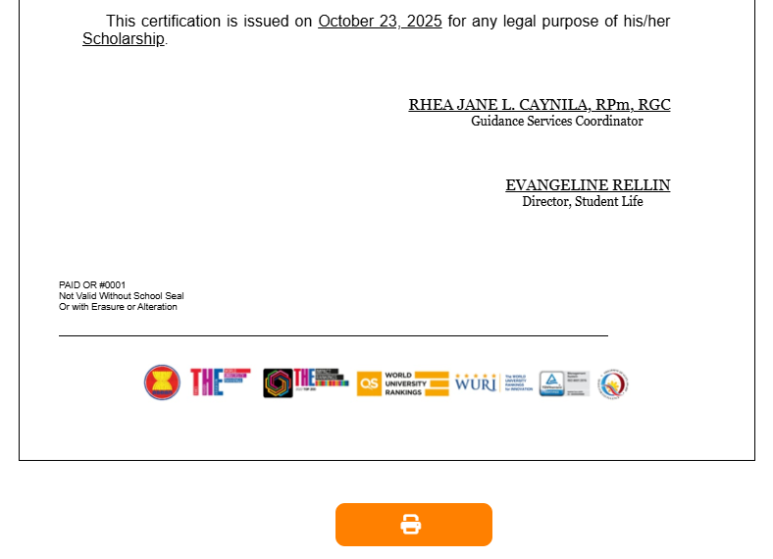
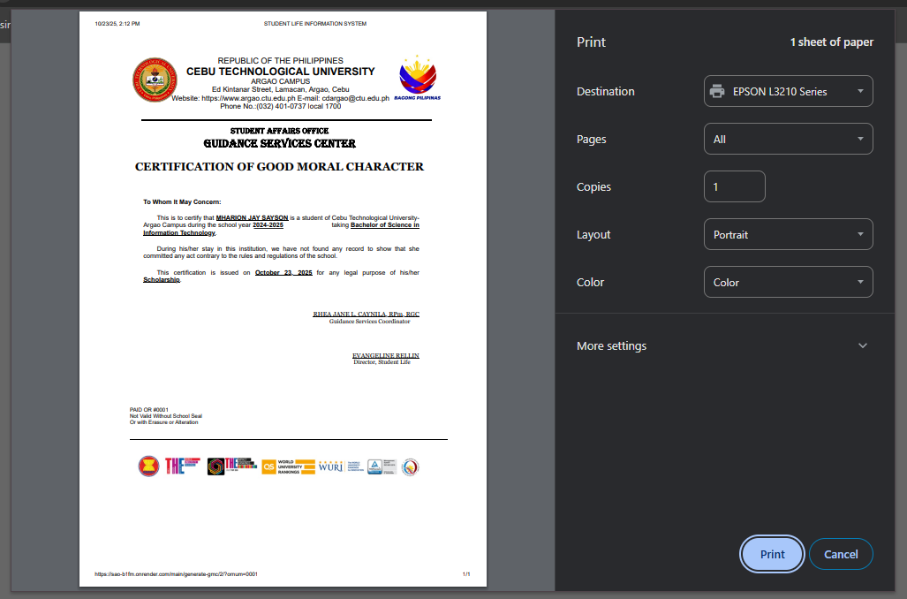


COLLEGE OF TECHNOLOGY AND ENGINEERING
Information Technology Department

USER ACCEPTANCE TESTING
Test Case ID | TC-Admin-0007
Capstone Project Title: | Student Affairs and Services System
Team | LOWCODE
 | Project Leader: |  |  | Honzel Babe Chavez
 |  |  |  | Kimberly Silvano
 | Front-End Programmer: |  |  | Jhudiel Anthony Carzano
 | QA Engineer: |  |  | Mharion Jay P. Sayson
 | Technical Writer: |  |  | Francis Xavier Sagarino
Title / Business Scenario | Verify that the admin can add a new activity to a specific date in the Monthly Calendar of Activities.
Preconditions | The admin is logged in with permission to access the Monthly Calendar of Activities module.
Test Data | Event Title: Student Leadership Seminar | Description: A seminar for student leaders. | Date: October 25, 2025 |  | Time: 8:30AM to 4PM
Steps | 1. Navigate to the Office of Student Life → Monthly Calendar of Activities page.
 | 2. Click on a specific date (e.g., October 25, 2025) that has no existing activities.
 | 3. Enter the event details (Title, Time, Location, Description).
 | 4. Click the Add/Save button.
Expected Result | After clicking Save, a confirmation popup appears with the message “Saved! Schedule has been added.”, and the new activity is displayed on the selected date in the calendar.
Actual Result (Pass/Fail) | Pass
Comments / Attachments (Screenshots, Logs) | Screenshot attached to the next page
Tester Name / Date | Mharion Jay P. Sayson / 10/15/2025
Panelist's Remarks
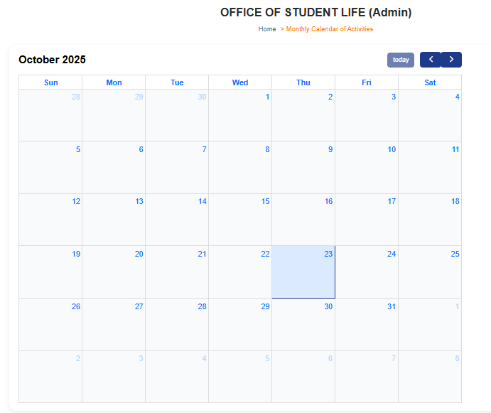
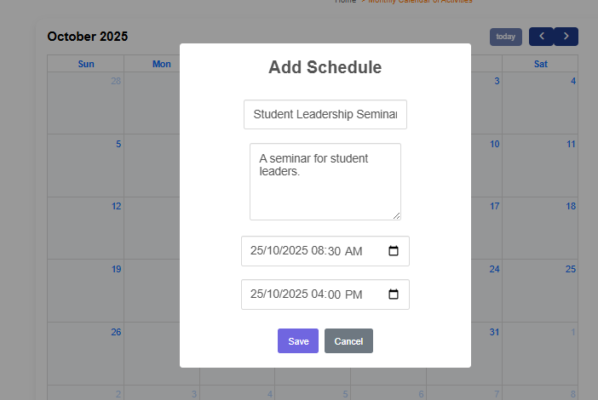
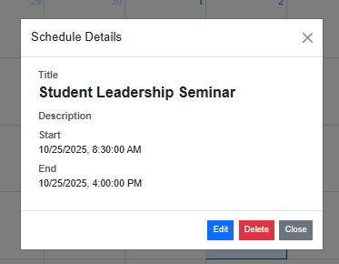
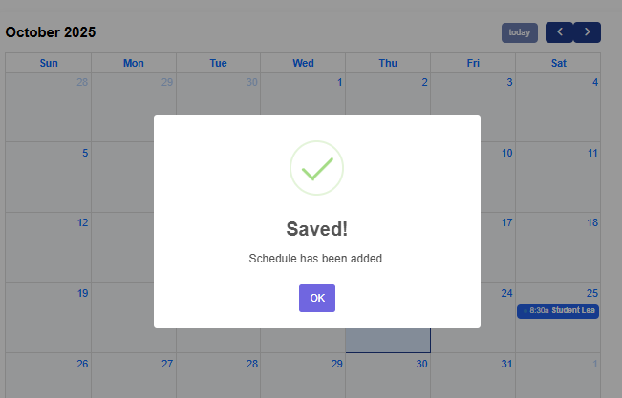



COLLEGE OF TECHNOLOGY AND ENGINEERING
Information Technology Department

USER ACCEPTANCE TESTING
Test Case ID | TC-Admin-0008
Capstone Project Title: | Student Affairs and Services System
Team | LOWCODE
 | Project Leader: |  | Honzel Babe Chavez
 |  |  | Kimberly Silvano
 | Front-End Programmer: |  | Jhudiel Anthony Carzano
 | QA Engineer: |  | Mharion Jay P. Sayson
 | Technical Writer: |  | Francis Xavier Sagarino
Title / Business Scenario | Verify that when the admin accepts a scholarship application, it becomes ready for requirements submission, and the student’s profile updates with active scholarship information.
Preconditions | The admin is logged in with access to the Scholarship Application Tracker module, and scholarship applications exist in the system.
Test Data | Student Id: 7181309 | Name: DEAN CLYDE VILLEGAS |  | Scholar Type: CHED - Full Merit
Steps | 1. Navigate to the Scholarship Application Tracker page.
 | 2. Search for the student using Application ID.
 | 3. Click the Accept button under the Confirmation column.
 | 4. Observe the confirmation message indicating the application has been accepted.
Expected Result | The system updates the student’s application status to Accepted, enabling the requirements submission phase, and on the user side, their profile displays:  - Scholarship Information: CHED - Full Merit  - Scholarship Status: ACTIVE
Actual Result (Pass/Fail) | Pass
Comments / Attachments (Screenshots, Logs) | Screenshot attached to the next page
Tester Name / Date | Mharion Jay P. Sayson / 10/15/2025
Panelist's Remarks
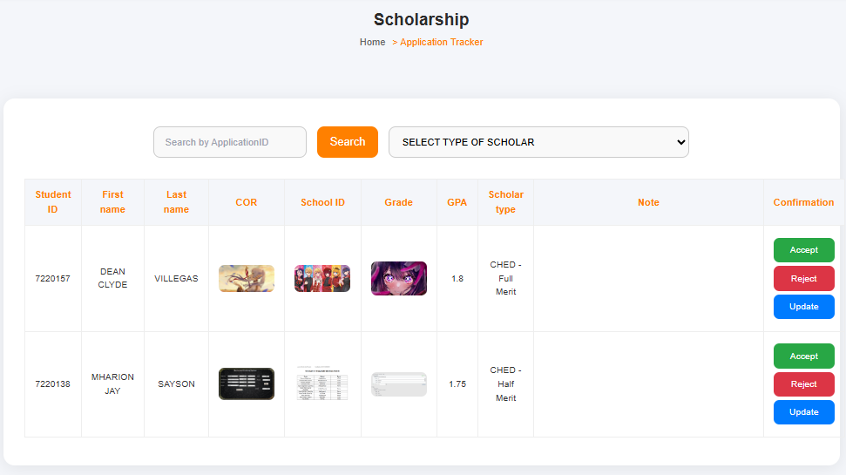

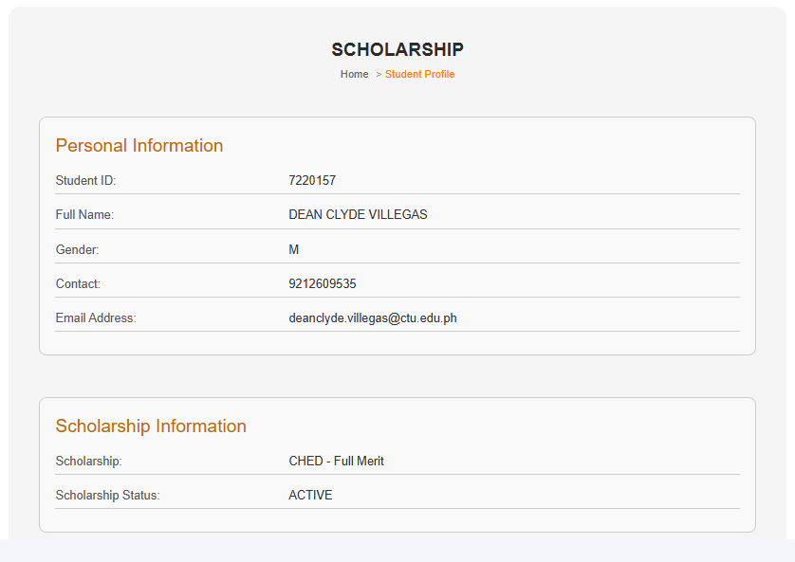



COLLEGE OF TECHNOLOGY AND ENGINEERING
Information Technology Department

USER ACCEPTANCE TESTING
Test Case ID | TC-Admin-0009
Capstone Project Title: | Student Affairs and Services System
Team | LOWCODE
 | Project Leader: |  | Honzel Babe Chavez
 |  |  | Kimberly Silvano
 | Front-End Programmer: |  | Jhudiel Anthony Carzano
 | QA Engineer: |  | Mharion Jay P. Sayson
 | Technical Writer: |  | Francis Xavier Sagarino
Title / Business Scenario | Verify that when the admin rejects a scholarship application, the student becomes eligible to submit a new application.
Preconditions | The admin is logged in with access to the Scholarship Application Tracker module, and scholarship applications exist in the system.
Test Data | Student Id: 7220138 | Name: MHARION JAY SAYSON |  | Scholar Type: CHED - Half Merit
Steps | 1. Navigate to the Scholarship Application Tracker page.
 | 2. Search for the student using Application ID.
 | 3. Click the Reject button under the Confirmation column.
 | 4. Observe the confirmation message indicating the application has been rejected.
Expected Result | The system updates the student’s application status to Rejected, displays a confirmation message, and on the user side, the student is allowed to submit a new scholarship application.
Actual Result (Pass/Fail) | Pass
Comments / Attachments (Screenshots, Logs) | Screenshot attached to the next page
Tester Name / Date | Mharion Jay P. Sayson / 10/15/2025
Panelist's Remarks
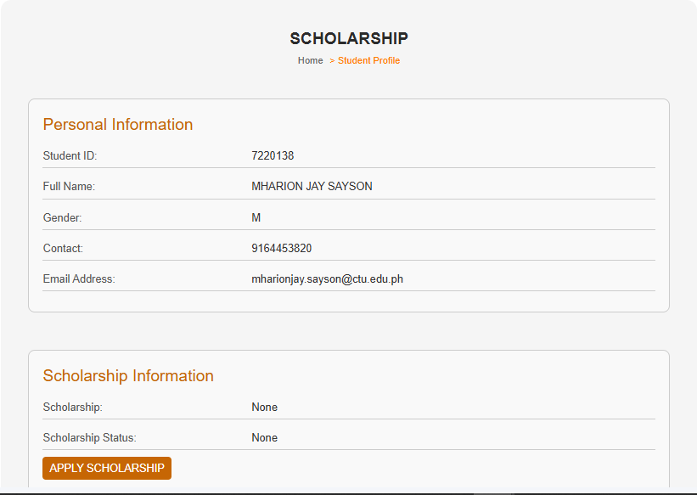
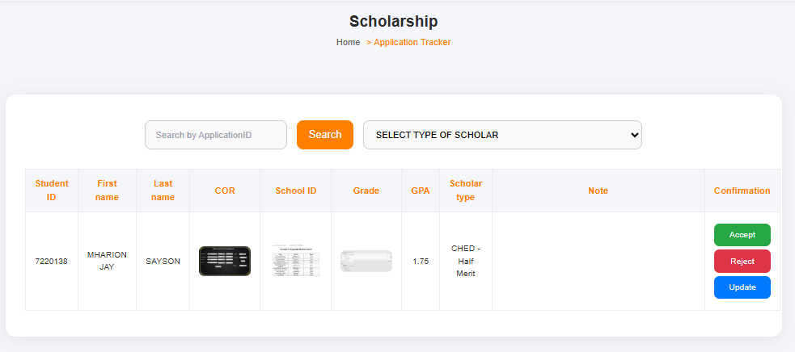


COLLEGE OF TECHNOLOGY AND ENGINEERING
Information Technology Department

USER ACCEPTANCE TESTING
Test Case ID | TC-Admin-0010
Capstone Project Title: | Student Affairs and Services System
Team | LOWCODE
 | Project Leader: | Honzel Babe Chavez
 |  | Kimberly Silvano
 | Front-End Programmer: | Jhudiel Anthony Carzano
 | QA Engineer: | Mharion Jay P. Sayson
 | Technical Writer: | Francis Xavier Sagarino
Title / Business Scenario | Verify that the admin can access the CHED TDP Scholarship Fund Utilization Form.
Preconditions | The admin is logged in and has access to the Admin Cost Liquidation Tracker module.
Test Data | N/A
Steps | 1. Navigate to the Admin Cost Liquidation Tracker module.
 | 2. Click the CHED TDP Scholarship card.
 | 3. Observe the page that loads.
Expected Result | The system redirects to the TDP Form – Annex 8 page displaying input fields for semester, academic year, fund utilization details, and disbursement entries.
Actual Result (Pass/Fail) | Pass
Comments / Attachments (Screenshots, Logs) | Screenshot attached to the next page
Tester Name / Date | Mharion Jay P. Sayson / 10/15/2025
Panelist's Remarks

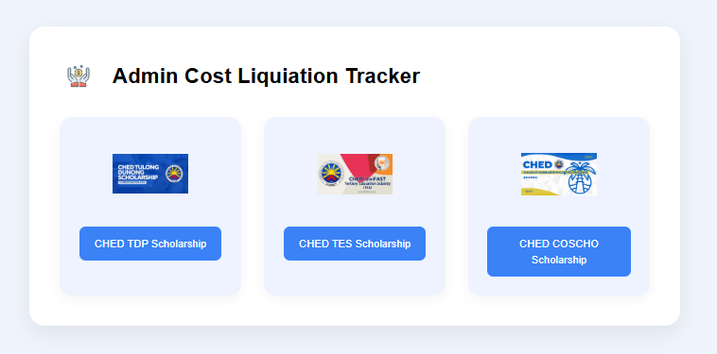
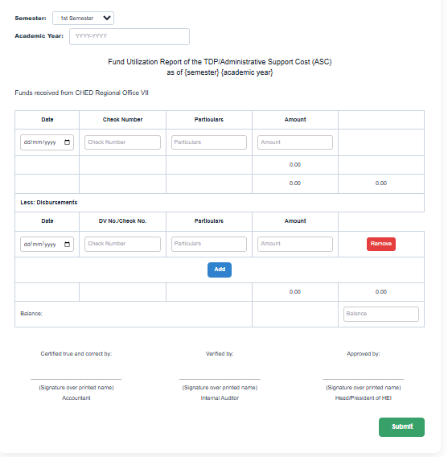



COLLEGE OF TECHNOLOGY AND ENGINEERING
Information Technology Department

USER ACCEPTANCE TESTING
Test Case ID | TC-Admin-0011
Capstone Project Title: | Student Affairs and Services System
Team | LOWCODE
 | Project Leader: | Honzel Babe Chavez
 |  | Kimberly Silvano
 | Front-End Programmer: | Jhudiel Anthony Carzano
 | QA Engineer: | Mharion Jay P. Sayson
 | Technical Writer: | Francis Xavier Sagarino
Title / Business Scenario | Verify that the admin can successfully add a new company in the OJT Hiring module under Job Placement.
Preconditions | The admin is logged in and has access to the Job Placement → OJT Hiring module.
Test Data | Company Name: ABC Tech Solutions  Address: Cebu City, Philippines  Owner: John Dela Cruz  Position: IT Support Intern  Company Contact: 09171234567  Shift: Day Shift  Slots: 5  Description: Accepting IT students for OJT program.
Steps | 1. Navigate to the Job Placement → OJT Hiring page.
 | 2. Click Add Company.
 | 3. Fill in all required company details and click Save or Submit.
Expected Result | The system redirects to the TDP Form – Annex 8 page displaying input fields for semester, academic year, fund utilization details, and disbursement entries.
Actual Result (Pass/Fail) | Pass
Comments / Attachments (Screenshots, Logs) | Screenshot attached to the next page
Tester Name / Date | Mharion Jay P. Sayson / 10/15/2025
Panelist's Remarks

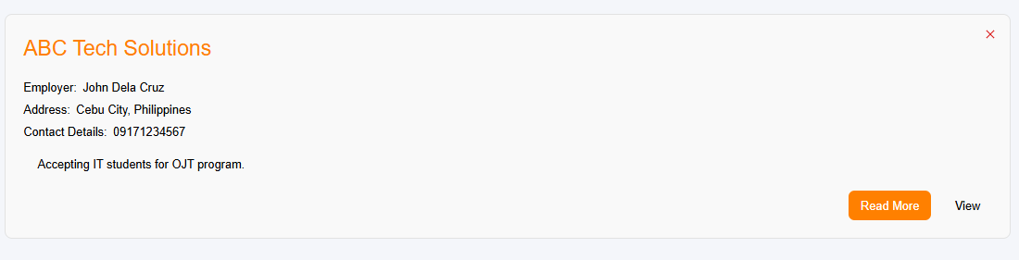


COLLEGE OF TECHNOLOGY AND ENGINEERING
Information Technology Department

USER ACCEPTANCE TESTING
Test Case ID | TC-Admin-0012
Capstone Project Title: | Student Affairs and Services System
Team | LOWCODE
 | Project Leader: | Honzel Babe Chavez
 |  | Kimberly Silvano
 | Front-End Programmer: | Jhudiel Anthony Carzano
 | QA Engineer: | Mharion Jay P. Sayson
 | Technical Writer: | Francis Xavier Sagarino
Title / Business Scenario | Verify that the admin can successfully add a new event in the Career Guidance Tracker module.
Preconditions | The admin is logged in and has access to the Career Guidance Tracker module.
Test Data | Title: Career Pathways Seminar  Theme: Exploring Opportunities in the IT Industry  Date of Event: 25/11/2025  Upload Image: school.jfif
Steps | 1. Navigate to the Career Guidance Tracker page.
 | 2. Click the Add Event button.
 | 3. Fill in all event details including title, theme, and date of event.
 | 4. Upload an image related to the event.
 | 5. Click Save or Submit.
Expected Result | The system successfully saves the event, displays a confirmation message (e.g., “Event added successfully”), and the event appears in the event list or calendar view.
Actual Result (Pass/Fail) | Pass
Comments / Attachments (Screenshots, Logs) | Screenshot attached to the next page
Tester Name / Date | Mharion Jay P. Sayson / 10/15/2025
Panelist's Remarks

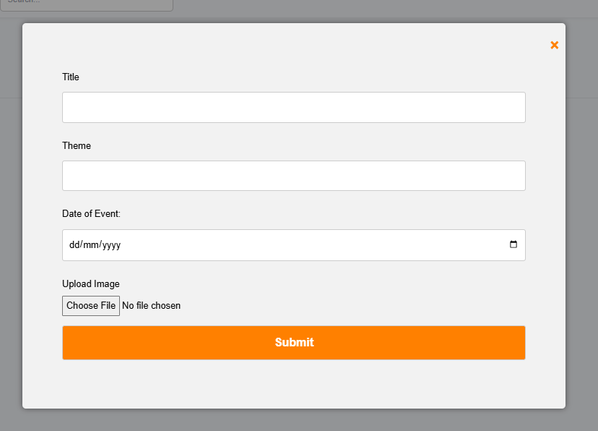
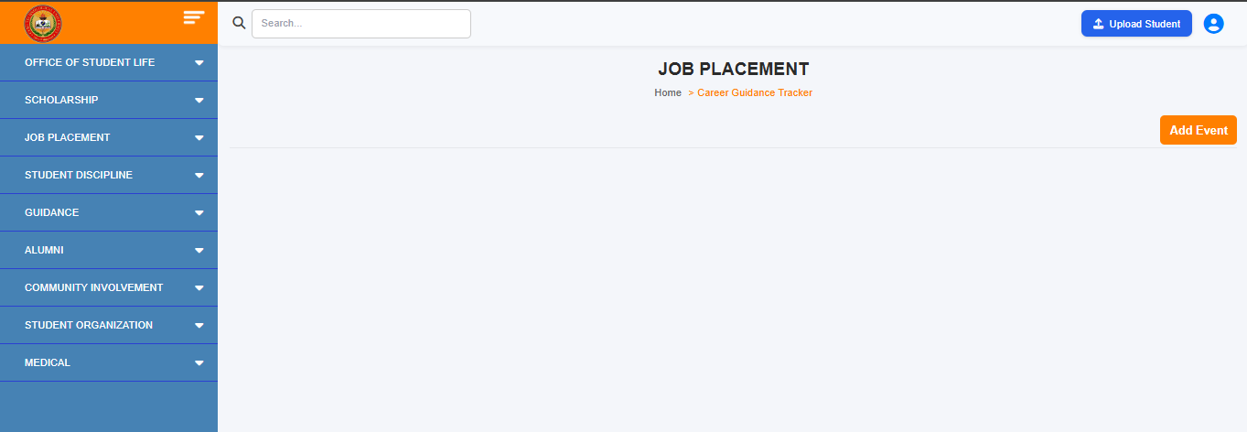
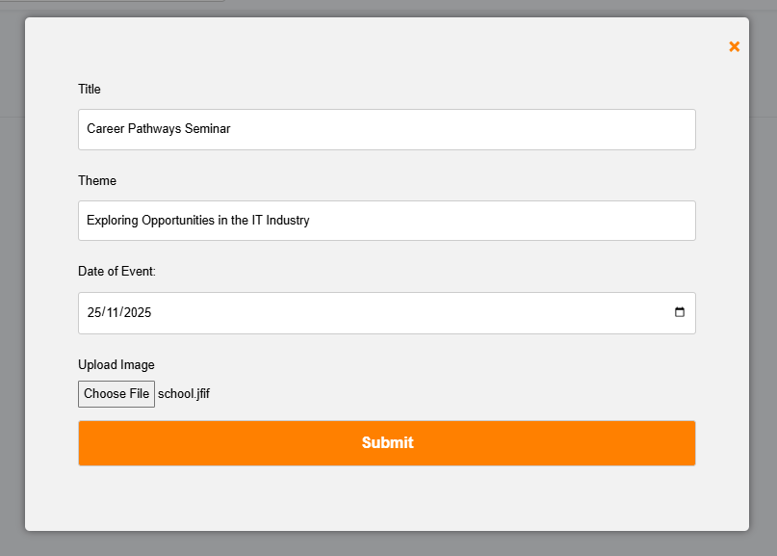
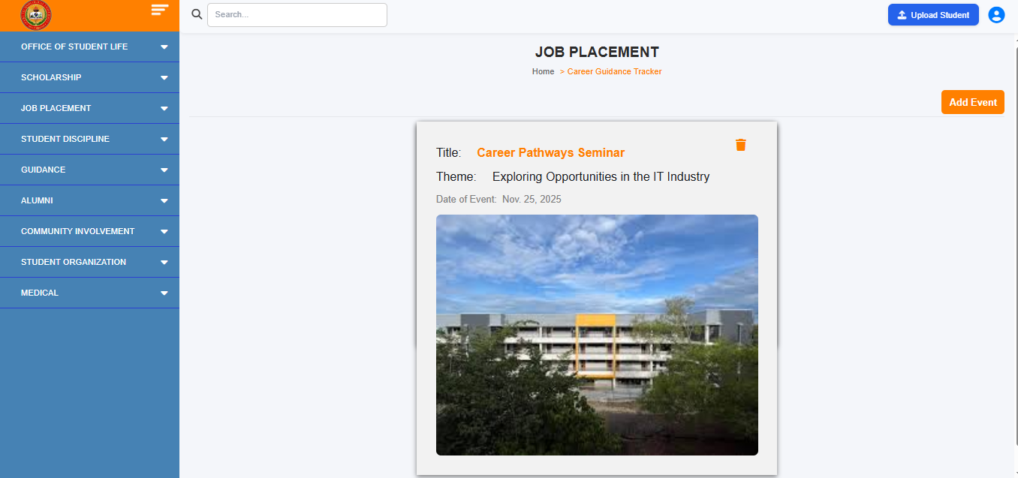


COLLEGE OF TECHNOLOGY AND ENGINEERING
Information Technology Department

USER ACCEPTANCE TESTING
Test Case ID | TC-Admin-0013
Capstone Project Title: | Student Affairs and Services System
Team | LOWCODE
 | Project Leader: | Honzel Babe Chavez
 |  | Kimberly Silvano
 | Front-End Programmer: | Jhudiel Anthony Carzano
 | QA Engineer: | Mharion Jay P. Sayson
 | Technical Writer: | Francis Xavier Sagarino
Title / Business Scenario | Verify that the admin can view uploaded OJT requirements submitted by students.
Preconditions | The admin is logged in and has access to the OJT Requirements Tracker module, and students have already uploaded their OJT requirements.
Test Data | Student ID: 7220151  Name: JHUDIEL ANTHONY CARZANO  Uploaded Requirements: Application Letter.pdf, Parent Consent.pdf, MOA.pdf
Steps | 1. Navigate to the Job Placement → OJT Hiring page.
 | 2. Search or select a student record from the list.
 | 3. Click the equivalent action button.
Expected Result | The system displays the list of uploaded OJT requirements with file names and allows the admin to open or download each document.
Actual Result (Pass/Fail) | Pass
Comments / Attachments (Screenshots, Logs) | Screenshot attached to the next page
Tester Name / Date | Mharion Jay P. Sayson / 10/15/2025
Panelist's Remarks
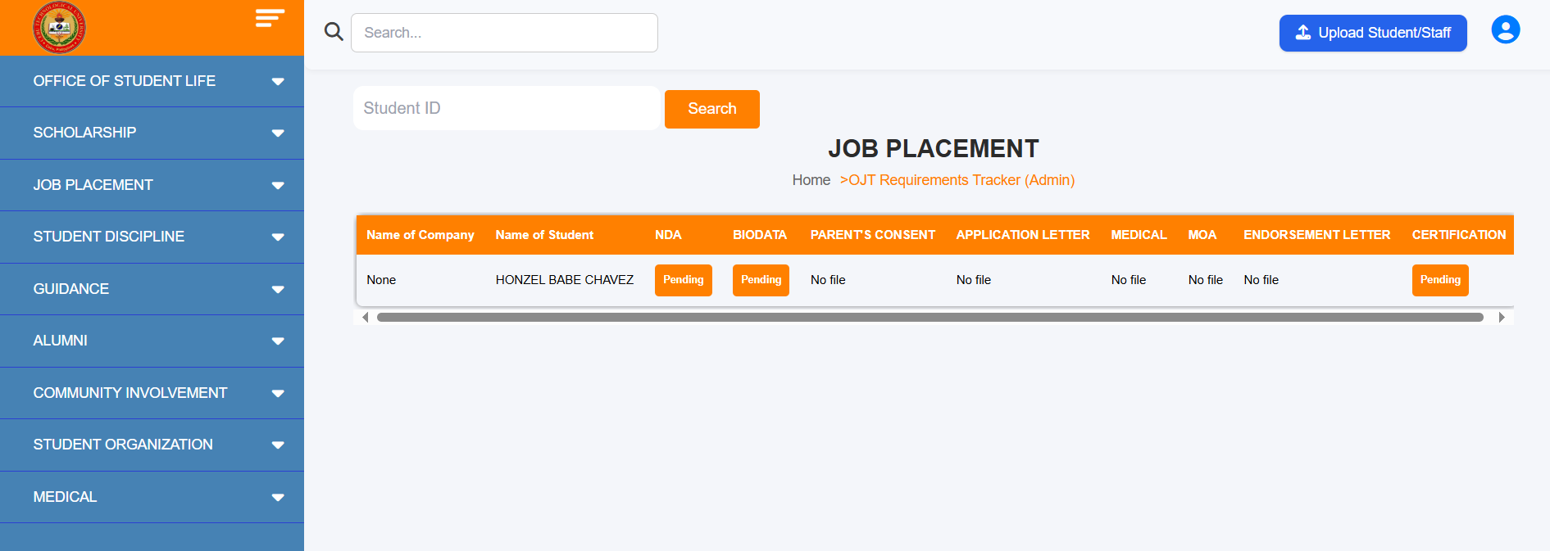
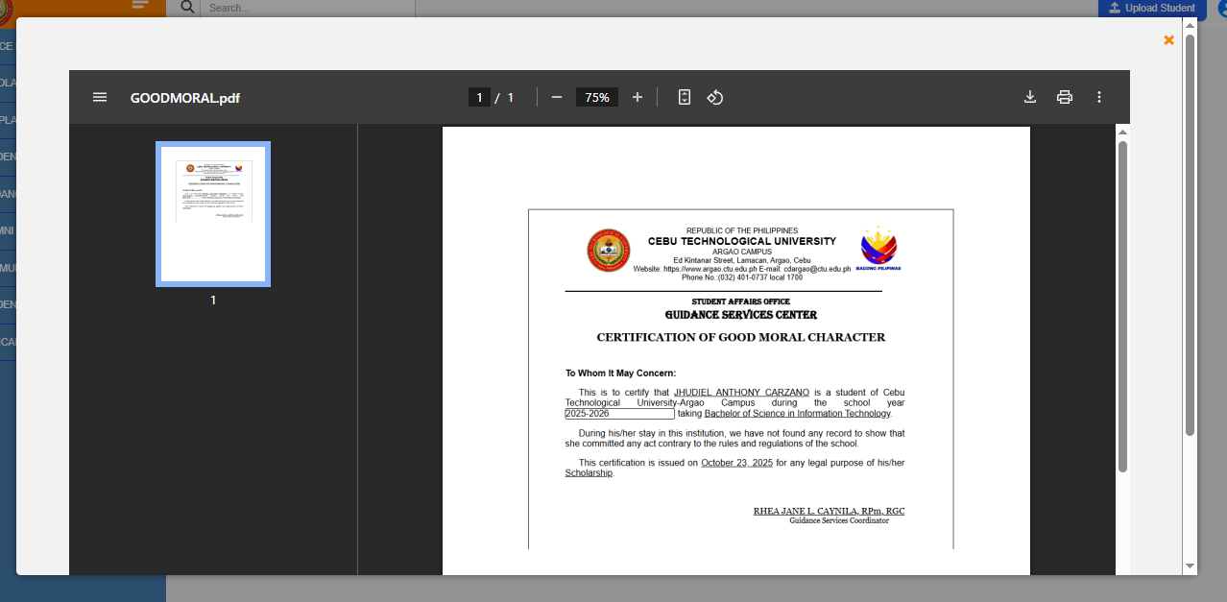


COLLEGE OF TECHNOLOGY AND ENGINEERING
Information Technology Department

USER ACCEPTANCE TESTING
Test Case ID | TC-Admin-0014
Capstone Project Title: | Student Affairs and Services System
Team | LOWCODE
 | Project Leader: | Honzel Babe Chavez
 |  | Kimberly Silvano
 | Front-End Programmer: | Jhudiel Anthony Carzano
 | QA Engineer: | Mharion Jay P. Sayson
 | Technical Writer: | Francis Xavier Sagarino
Title / Business Scenario | Verify that the admin can check, approve, or decline OJT requirements submitted by students.
Preconditions | The admin is logged in and has access to the OJT Requirements Tracker module.  Students have already uploaded their OJT requirements for review.
Test Data | Student ID: 7220151  Name: JHUDIEL ANTHONY CARZANO  Uploaded Requirements: Application Letter.pdf, Parent Consent.pdf, MOA.pdf
Steps | 1. Navigate to the Job Placement → OJT Hiring page.
 | 2. Search or select a student record from the list.
 | 3. Click the equivalent action button to view the submitted requirements.
 | 4. Review each uploaded document.
 | 5. Click Approve or Decline for each requirement or for the entire submission.
Expected Result | The system displays the list of uploaded OJT requirements with file names and allows the admin to open or download each document.
Actual Result (Pass/Fail) | Pass
Comments / Attachments (Screenshots, Logs) | Screenshot attached to the next page
Tester Name / Date | Mharion Jay P. Sayson / 10/15/2025
Panelist's Remarks
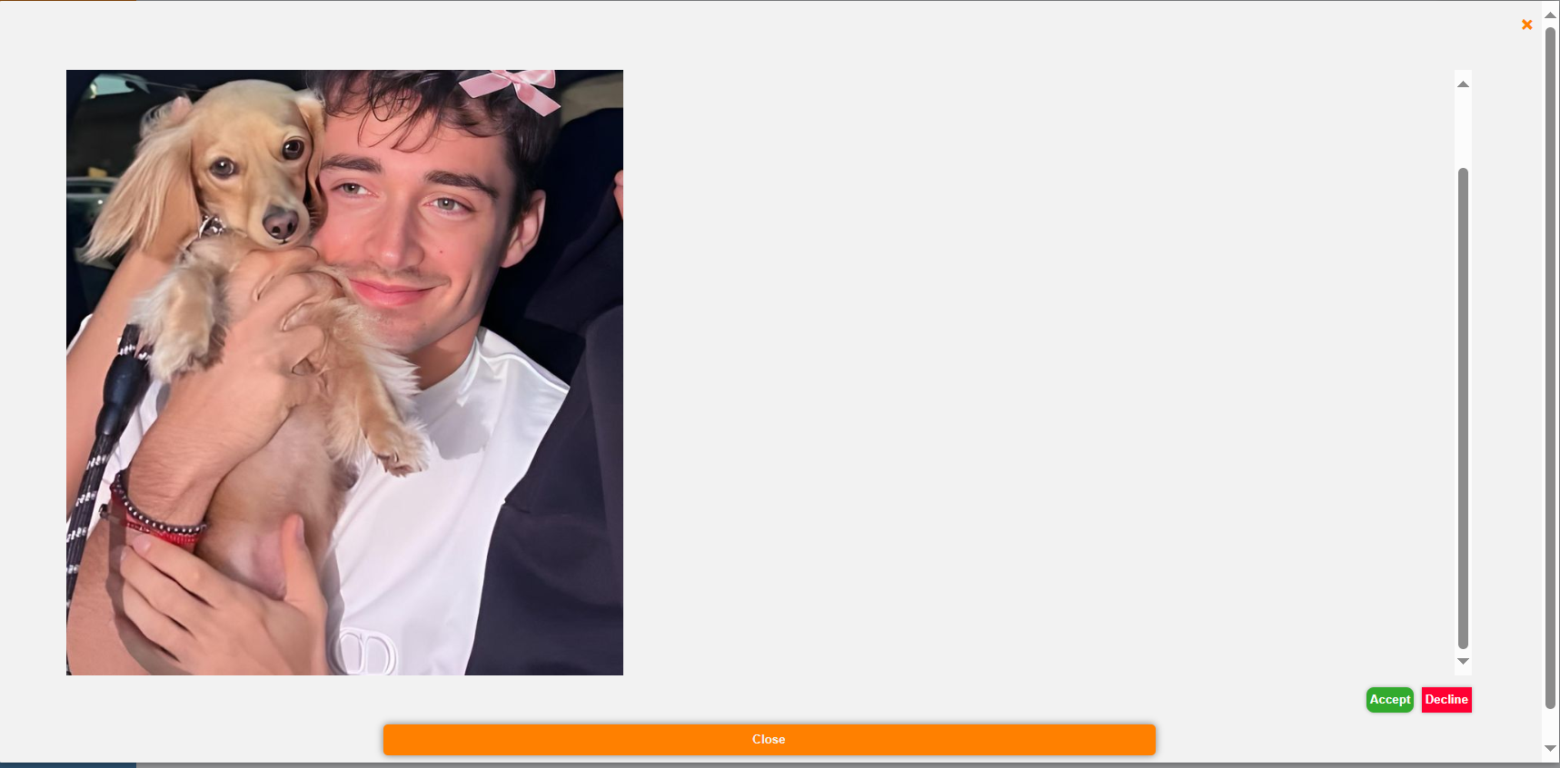
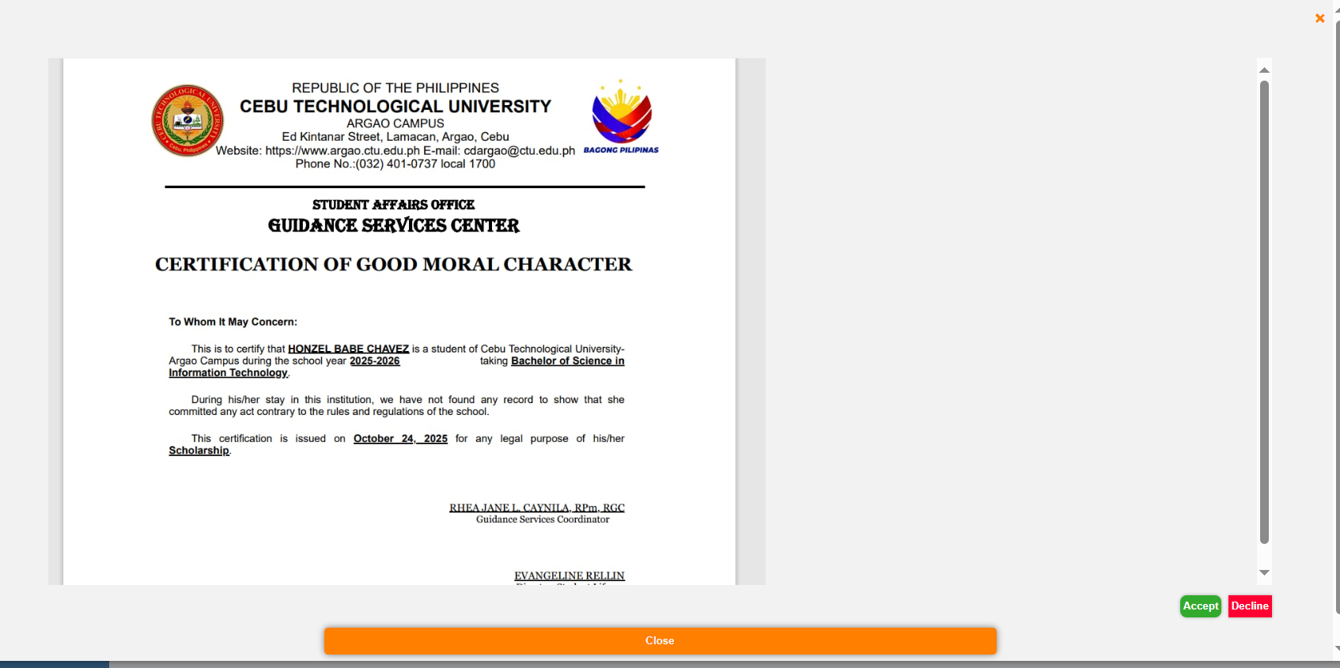
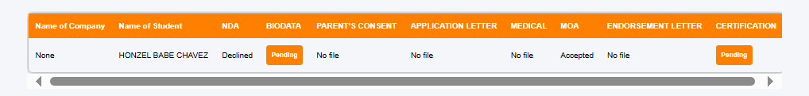

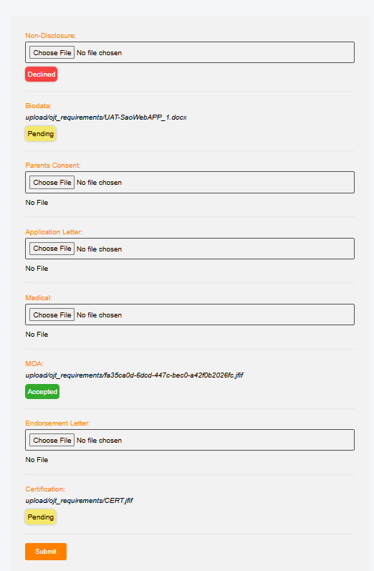



COLLEGE OF TECHNOLOGY AND ENGINEERING
Information Technology Department

USER ACCEPTANCE TESTING
Test Case ID | TC-Admin-0015
Capstone Project Title: | Student Affairs and Services System
Team | LOWCODE
 | Project Leader: |  |  |  | Honzel Babe Chavez
 |  |  |  |  | Kimberly Silvano
 | Front-End Programmer: |  |  |  | Jhudiel Anthony Carzano
 | QA Engineer: |  |  |  | Mharion Jay P. Sayson
 | Technical Writer: |  |  |  | Francis Xavier Sagarino
Title / Business Scenario | Create a new student offense record by filling out the Case Profile form.
Preconditions | The user must be logged in as an authorized staff member with access to the Case Profile page.
Test Data | Student Id: 7181309 | Offense: Cheating | Action: Suspension | Days: 14 |  | Status: Pending | Attach file:  (Optional)
Steps | 1. Enter a valid Student ID.
 | 2. Select an Offense Type (Cheating, Bullying, or Others) and fill in Description field.
 | 3. Choose an Action Taken (Community Service, Suspension, Counseling).
 | 4. Enter Hours/Days as applicable.
 | 5. Click Upload Attachment to add a file or skip this step and click Submit.
Expected Result | User should be redirected to the dashboard or homepage.
Actual Result (Pass/Fail) | Pass
Comments / Attachments (Screenshots, Logs) | Screenshot attached to the next page
Tester Name / Date | Mharion Jay P. Sayson / 10/15/2025
Panelist's Remarks
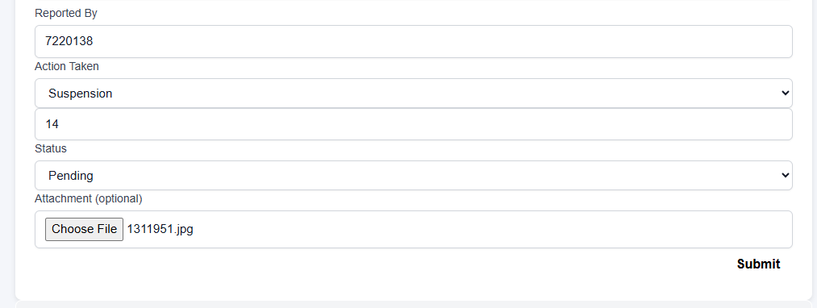
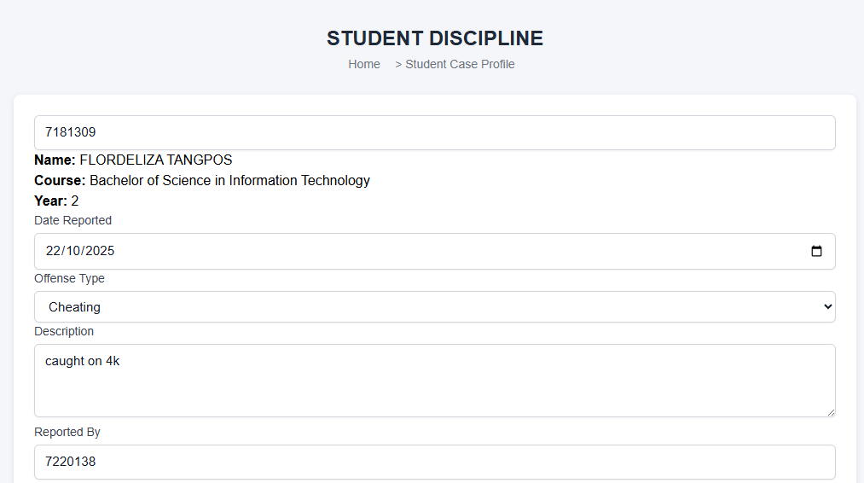



COLLEGE OF TECHNOLOGY AND ENGINEERING
Information Technology Department

USER ACCEPTANCE TESTING
Test Case ID | TC-Admin-0016
Capstone Project Title: | Student Affairs and Services System
Team | LOWCODE
 | Project Leader: | Honzel Babe Chavez
 |  | Kimberly Silvano
 | Front-End Programmer: | Jhudiel Anthony Carzano
 | QA Engineer: | Mharion Jay P. Sayson
 | Technical Writer: | Francis Xavier Sagarino
Title / Business Scenario | Validate auto-display of student details upon entering Student ID.
Preconditions | The student must exist in the student database.
Test Data | Student ID: 7211464
Steps | 1. Navigate to Student Discipline → Case Profile.
 | 2. Input a valid Student ID.
 | 3. Observe if fields such as Full Name, Year and Program are automatically displayed.
Expected Result | Student information fields populate automatically based on entered ID.
Actual Result (Pass/Fail) | Pass
Comments / Attachments (Screenshots, Logs) | Screenshot attached to the next page
Tester Name / Date | Mharion Jay P. Sayson / 10/15/2025
Panelist's Remarks
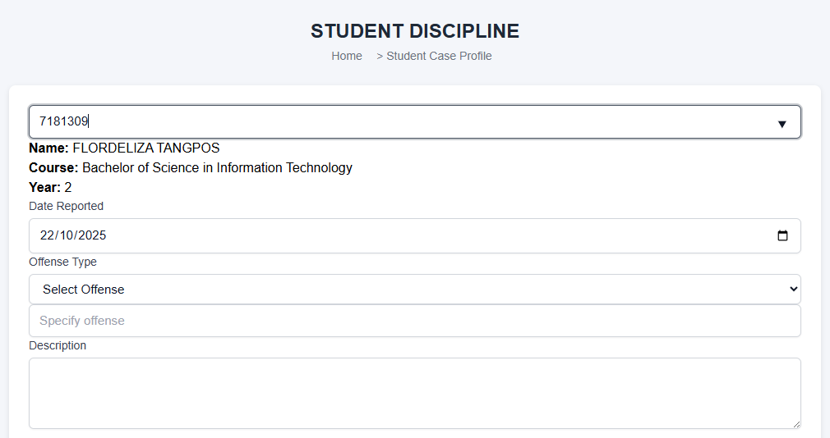
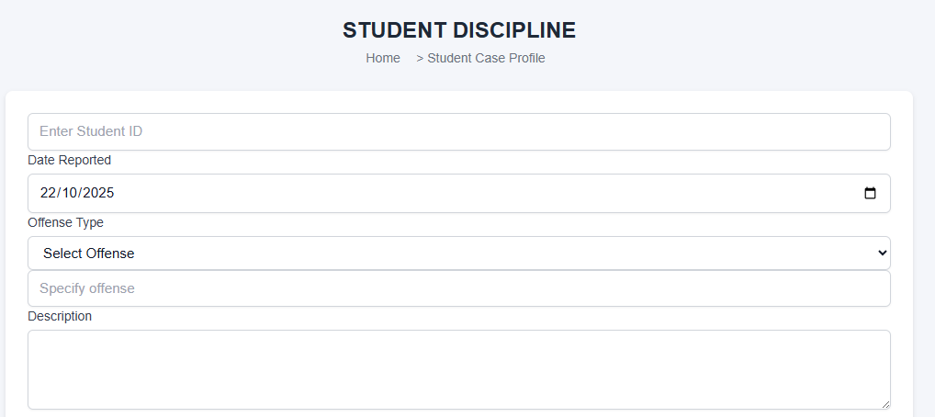



COLLEGE OF TECHNOLOGY AND ENGINEERING
Information Technology Department

USER ACCEPTANCE TESTING
Test Case ID | TC-Admin-0016
Capstone Project Title: | Student Affairs and Services System
Team | LOWCODE
 | Project Leader: |  | Honzel Babe Chavez
 |  |  | Kimberly Silvano
 | Front-End Programmer: |  | Jhudiel Anthony Carzano
 | QA Engineer: |  | Mharion Jay P. Sayson
 | Technical Writer: |  | Francis Xavier Sagarino
Title / Business Scenario | Verify that selecting “Others” in Offense Type enables a text field for specifying offense.
Preconditions | The user must be logged in as an authorized staff member with access to the Case Profile page.
Test Data | Offense Type: Others | Custom Offense: Vandalism
Steps | 1. Select Offense Type → Others.
 | 2. Check that a new field appears allowing custom offense input.
 | 3. Enter a custom offense (e.g., “Vandalism”) and submit the record.
Expected Result | Student information fields populate automatically based on entered ID.
Actual Result (Pass/Fail) | Pass
Comments / Attachments (Screenshots, Logs) | Screenshot attached to the next page
Tester Name / Date | Mharion Jay P. Sayson / 10/15/2025
Panelist's Remarks

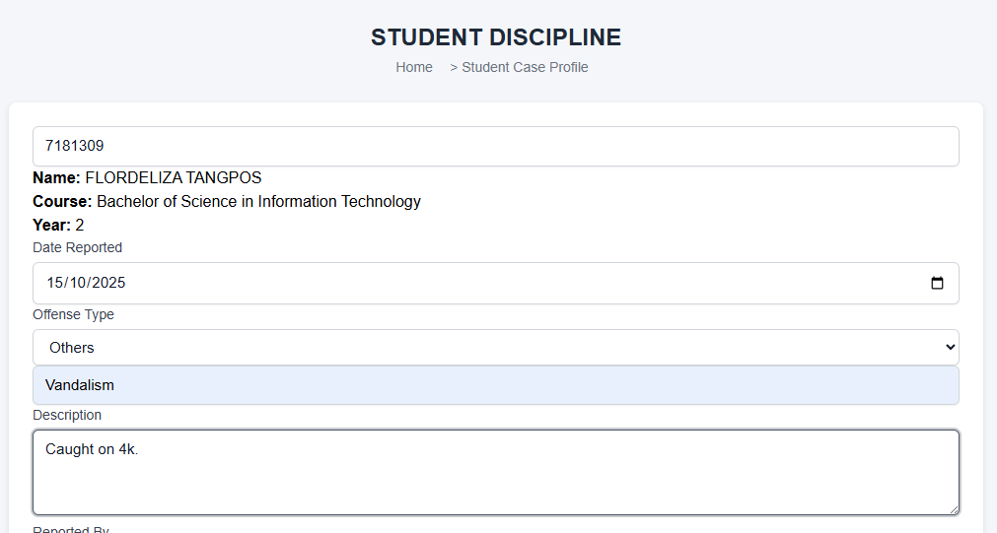


COLLEGE OF TECHNOLOGY AND ENGINEERING
Information Technology Department

USER ACCEPTANCE TESTING
Test Case ID | TC-Admin-0017
Capstone Project Title: | Student Affairs and Services System
Team | LOWCODE
 | Project Leader: |  | Honzel Babe Chavez
 |  |  | Kimberly Silvano
 | Front-End Programmer: |  | Jhudiel Anthony Carzano
 | QA Engineer: |  | Mharion Jay P. Sayson
 | Technical Writer: |  | Francis Xavier Sagarino
Title / Business Scenario | Verify deleting a disciplinary record.
Preconditions | The user is logged in with the appropriate role (e.g., Admin or Staff) that has permission to delete disciplinary records.
Test Data | Offense Type: Others | Custom Offense: Vandalism
Steps | 1. Click Delete beside a record.
 | 2. Confirm deletion.
3. A confirmation popup appears with the message:
“Are you sure? This action cannot be undone.”
 | 4. Click Yes, delete it! to confirm; A success popup appears with the message: “Deleted! The case has been deleted.”
 | 5. Click OK to close the confirmation message.
Expected Result | The selected disciplinary record is permanently removed from the table.
Actual Result (Pass/Fail) | Pass
Comments / Attachments (Screenshots, Logs) | Screenshot attached to the next page
Tester Name / Date | Jhudiel Anthony Carzano / 10/15/2025
Panelist's Remarks
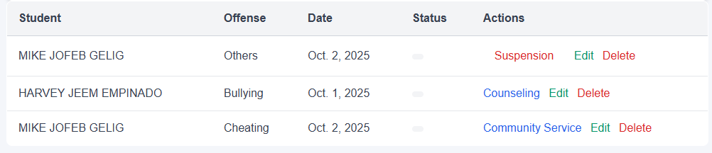
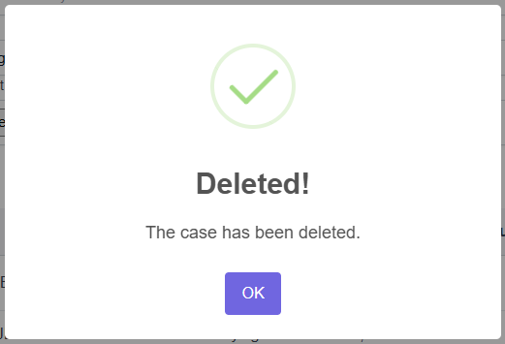
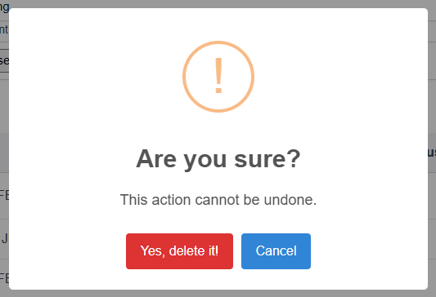
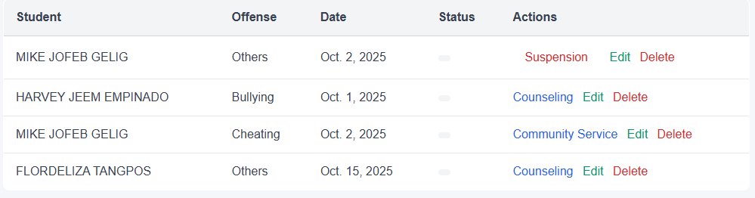



COLLEGE OF TECHNOLOGY AND ENGINEERING
Information Technology Department

USER ACCEPTANCE TESTING
Test Case ID | TC-Admin-0018
Capstone Project Title: | Student Affairs and Services System
Team | LOWCODE
 | Project Leader: |  | Honzel Babe Chavez
 |  |  | Kimberly Silvano
 | Front-End Programmer: |  | Jhudiel Anthony Carzano
 | QA Engineer: |  | Mharion Jay P. Sayson
 | Technical Writer: |  | Francis Xavier Sagarino
Title / Business Scenario | Verify that the admin can edit existing student case information in the Case Profile module.
Preconditions | The user must be logged in as an authorized staff member with access to the Case Profile page.
Test Data | Action Taken: Community service | Community Service hours: 2
Steps | 1. Navigate to Student Discipline → Case Profile.
 | 2. Click the Edit button beside the selected record.
 | 3. Modify the necessary fields.
Expected Result | The system successfully updates the student’s case information.  A confirmation message appears, and the modified details are reflected in the Case Profile list.
Actual Result (Pass/Fail) | Pass
Comments / Attachments (Screenshots, Logs) | Screenshot attached to the next page
Tester Name / Date | Mharion Jay P. Sayson / 10/15/2025
Panelist's Remarks

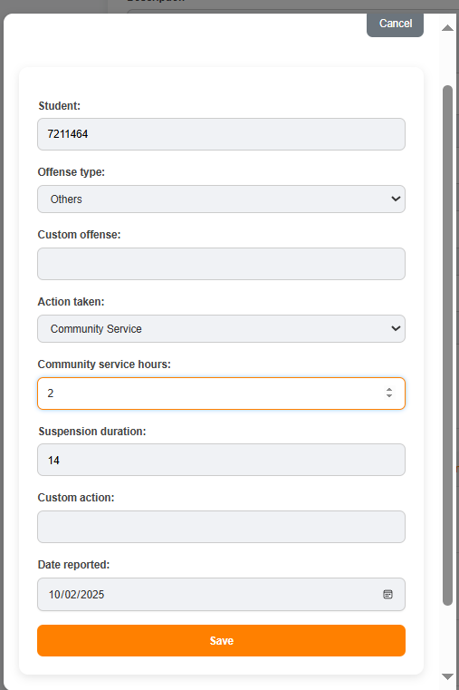


COLLEGE OF TECHNOLOGY AND ENGINEERING
Information Technology Department

USER ACCEPTANCE TESTING
Test Case ID | TC-Admin-0019
Capstone Project Title: | Student Affairs and Services System
Team | LOWCODE
 | Project Leader: | Honzel Babe Chavez
 |  | Kimberly Silvano
 | Front-End Programmer: | Jhudiel Anthony Carzano
 | QA Engineer: | Mharion Jay P. Sayson
 | Technical Writer: | Francis Xavier Sagarino
Title / Business Scenario | Verify that the Guidance (Admin) can accept a pending counseling schedule.
Preconditions | The user must be logged in as an authorized Guidance (Admin) staff member. The user must be on the "Counseling App with Schedule" page. There must be at least one student request with a "Pending" status.
Test Data | Student Record: Harvey Jeem Emfinado (or any record with 'Pending' status)
Steps | 1. Navigate to the "Counseling App with Schedule" page
 | 2. Locate the student record to be accepted (e.g., Harvey Jeem Emfinado).
 | 3. Click the green "ACCEPT" button corresponding to that student's record.
Expected Result | The system successfully accepts the schedule. A confirmation message (e.g., "Schedule accepted!") appears. The "Status" for that record changes from "Pending" to "Accepted" or "Confirmed".
Actual Result (Pass/Fail) | Pass
Comments / Attachments (Screenshots, Logs) | Screenshot attached to the next page
Tester Name / Date | Mharion Jay P. Sayson / 10/15/2025
Panelist's Remarks
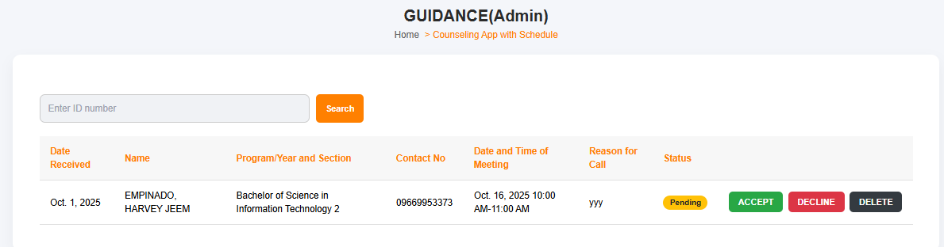



COLLEGE OF TECHNOLOGY AND ENGINEERING
Information Technology Department

USER ACCEPTANCE TESTING
Test Case ID | TC-Admin-0020
Capstone Project Title: | Student Affairs and Services System
Team | LOWCODE
 | Project Leader: | Honzel Babe Chavez
 |  | Kimberly Silvano
 | Front-End Programmer: | Jhudiel Anthony Carzano
 | QA Engineer: | Mharion Jay P. Sayson
 | Technical Writer: | Francis Xavier Sagarino
Title / Business Scenario | Verify that the Alumni (Admin) can approve a pending Alumni ID request.
Preconditions | The user must be logged in as an authorized Alumni (Admin) staff member. The user must be on the "ID request" page. There must be at least one Alumni ID request with a pending status (indicated by the "Approve" button).
Test Data | Alumni Record: Honzel Babe Chavez Date Requested: Oct. 27, 2025
Steps | 1. Navigate to the Home → ID request page.
 | 2. Locate the pending Alumni ID request (e.g., for Honzel Babe Chavez).
 | 3. Click the orange "Approve" button corresponding to that record.
Expected Result | The system successfully approves the Alumni ID request. A confirmation message (e.g., "ID request approved!") appears. The "Date Released" field is automatically populated with the current date (or the date of approval). The "Confirmation" button changes from "Approve" to a status indicator (e.g., "Approved" or "Released").
Actual Result (Pass/Fail) | Pass
Comments / Attachments (Screenshots, Logs) | Screenshot attached to the next page
Tester Name / Date | Mharion Jay P. Sayson / 10/15/2025
Panelist's Remarks

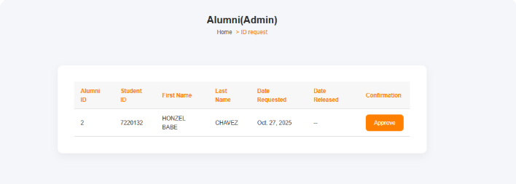
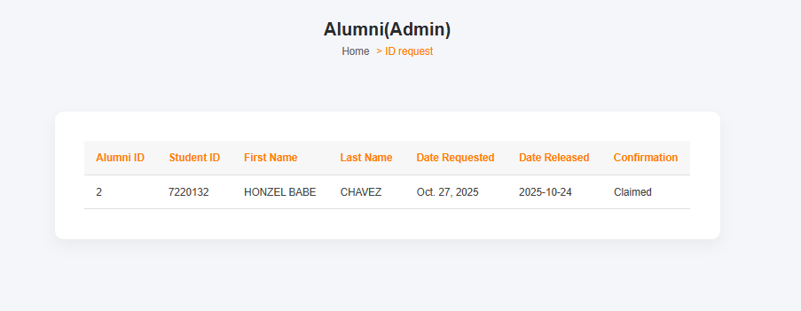



COLLEGE OF TECHNOLOGY AND ENGINEERING
Information Technology Department

USER ACCEPTANCE TESTING
Test Case ID | TC-Admin-0021
Capstone Project Title: | Student Affairs and Services System
Team | LOWCODE
 | Project Leader: | Honzel Babe Chavez
 |  | Kimberly Silvano
 | Front-End Programmer: | Jhudiel Anthony Carzano
 | QA Engineer: | Mharion Jay P. Sayson
 | Technical Writer: | Francis Xavier Sagarino
Title / Business Scenario | Verify that the Alumni (Admin) can successfully create and publish a new Alumni Event.
Preconditions | The user must be logged in as an authorized Alumni (Admin) staff member. The user must be on the Home → Admin Events page.
Test Data | Event Name: Alumni Grand Homecoming Event Date: 12/31/2025 Event Location: Kalampusan Gym Event Description: Annual gathering for all alumni to reconnect and celebrate the university's milestone. Upload Image: A valid image file (e.g., homecoming_banner.jpg)
Steps | 1. Navigate to the Home → Admin Events page.
 | 2. Enter the Event Name (e.g., Alumni Grand Homecoming).
 | 3. Enter the Event Date (e.g., 12/15/2025).
 | 4. Enter the Event Location (e.g., University Gymnasium).
 | 5. Enter the Event Description.
 | 6. Click "Choose File" and upload an image.
 | 7. Click the submission button (implied: button not fully visible, assume it's "Submit" or "Create Event").
Expected Result | The system successfully creates the new event. A confirmation message (e.g., "Event successfully created!") appears. The new event is displayed in the list of published Alumni Events.
Actual Result (Pass/Fail) | Pass
Comments / Attachments (Screenshots, Logs) | Screenshot attached to the next page
Tester Name / Date | Mharion Jay P. Sayson / 10/15/2025
Panelist's Remarks
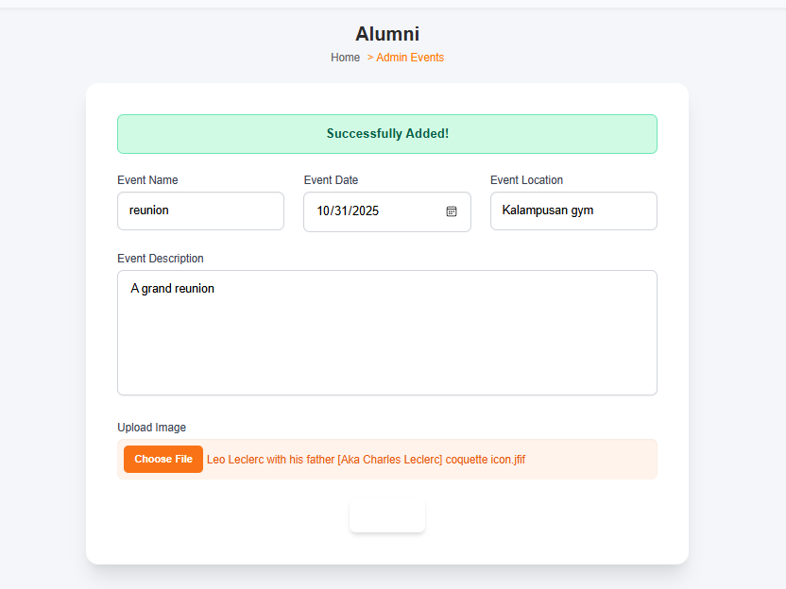
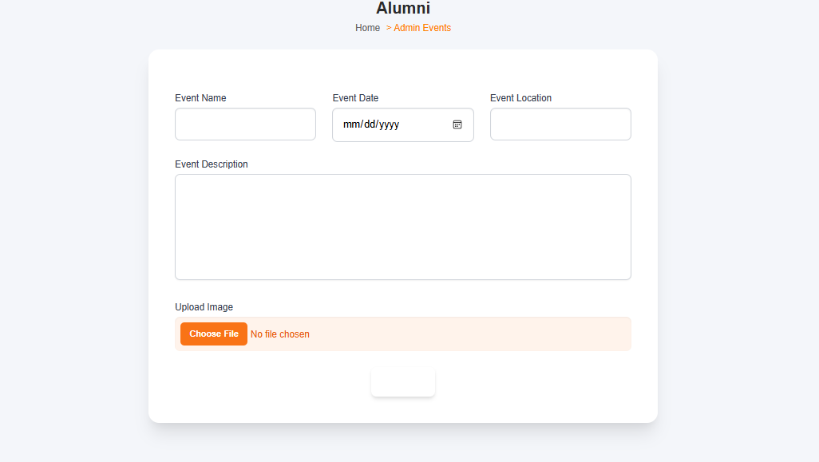
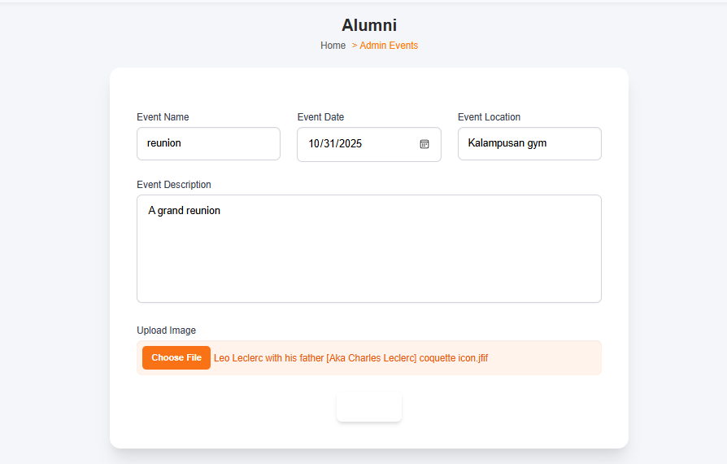


COLLEGE OF TECHNOLOGY AND ENGINEERING
Information Technology Department

USER ACCEPTANCE TESTING
Test Case ID | TC-Admin-0022
Capstone Project Title: | Student Affairs and Services System
Team | LOWCODE
 | Project Leader: | Honzel Babe Chavez
 |  | Kimberly Silvano
 | Front-End Programmer: | Jhudiel Anthony Carzano
 | QA Engineer: | Mharion Jay P. Sayson
 | Technical Writer: | Francis Xavier Sagarino
Title / Business Scenario | Verify that the Alumni (Admin) can successfully create and publish a new Job Posting in the Jobfairs module.
Preconditions | The user must be logged in as an authorized Alumni (Admin) staff member. The user must be on the Home → Admin Jobfairs page.
Test Data | Job Title: Senior Full Stack Developer  Company Name: Tech Solutions Inc.  Location: Cebu City, Philippines  Employment Type: Full-Time  Job Salary: ₱60,000 - ₱80,000  Application Deadline: 10/25/2025  Date Posted: 10/24/2025 (or current date)  Job Description: Develop and maintain web applications, collaborating with the design and product teams. Must have 5+ years of experience.
Steps | 1. Navigate to the Home → Admin Events page.
 | 2. Enter the Event Name (e.g., Alumni Grand Homecoming).
 | 3. Enter the Event Date (e.g., 12/15/2025).
 | 4. Enter the Event Location (e.g., University Gymnasium).
 | 5. Enter the Event Description.
 | 6. Click "Choose File" and upload an image.
 | 7. Click the submission button (implied: button not fully visible, assume it's "Submit" or "Create Event").
Expected Result | The system successfully creates the new event. A confirmation message (e.g., "Event successfully created!") appears. The new event is displayed in the list of published Alumni Events.
Actual Result (Pass/Fail) | Pass
Comments / Attachments (Screenshots, Logs) | Screenshot attached to the next page
Tester Name / Date | Mharion Jay P. Sayson / 10/15/2025
Panelist's Remarks
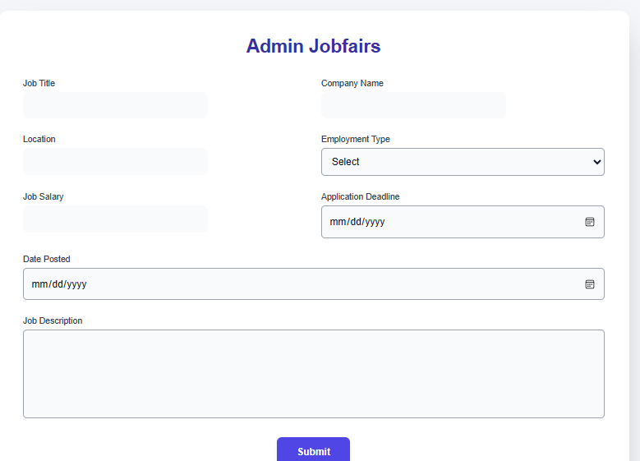

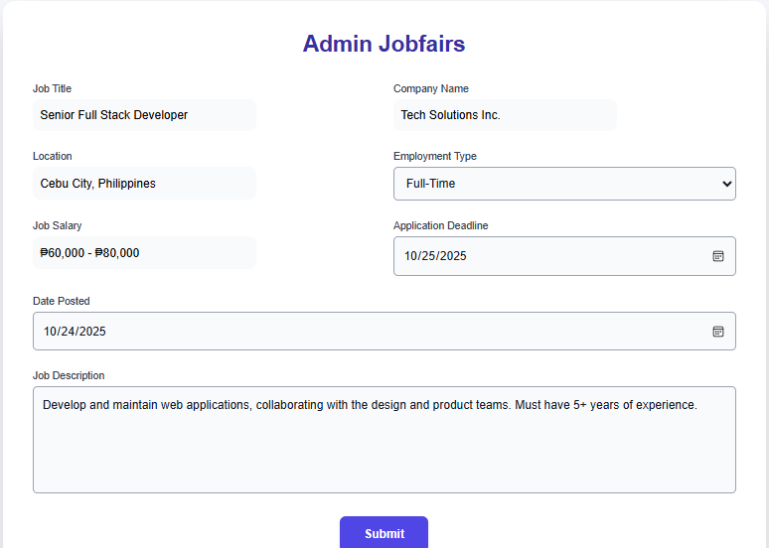

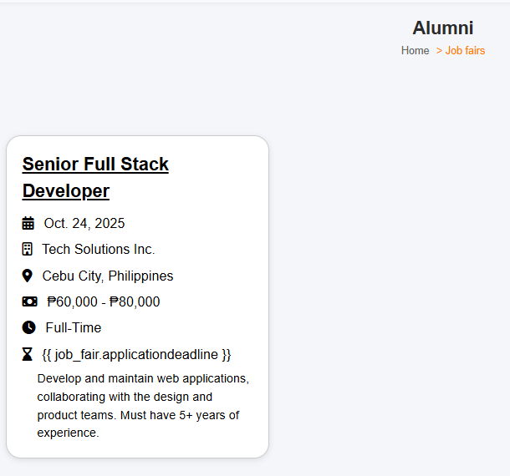



COLLEGE OF TECHNOLOGY AND ENGINEERING
Information Technology Department

USER ACCEPTANCE TESTING
Test Case ID | TC-Admin-0023
Capstone Project Title: | Student Affairs and Services System
Team | LOWCODE
 | Project Leader: | Honzel Babe Chavez
 |  | Kimberly Silvano
 | Front-End Programmer: | Jhudiel Anthony Carzano
 | QA Engineer: | Mharion Jay P. Sayson
 | Technical Writer: | Francis Xavier Sagarino
Title / Business Scenario | Verify that an authorized user can successfully create and publish a new quick post/announcement under the "Community Involvement" Events page.
Preconditions | The user must be logged in as an authorized Admin or Staff member with posting privileges. The user must be on the Home → Events page (Community Involvement).
Test Data | Event Name : Mental Health Awareness  Event Date: 12/31/2025  Event Image: Mental.jpg (Image must be visible)
Steps | 1. Go to the "COMMUNITY INVOLVEMENT" page.
 | 2. Enter the post content (e.g., "Mental Health Awareness.") into the text area.
 | 3. Click the "Photo/Video" button and upload an image (e.g., election_poster.png).
 | 4. Verify the correct image and title are displayed.
 | 5. Click the orange "Post" button.
Expected Result | The post is successfully published and appears as the top item in the list of Community Involvement entries. A confirmation message (e.g., "Post submitted successfully!") should appear.
Actual Result (Pass/Fail) | Pass
Comments / Attachments (Screenshots, Logs) | Screenshot attached to the next page
Tester Name / Date | Mharion Jay P. Sayson / 10/15/2025
Panelist's Remarks
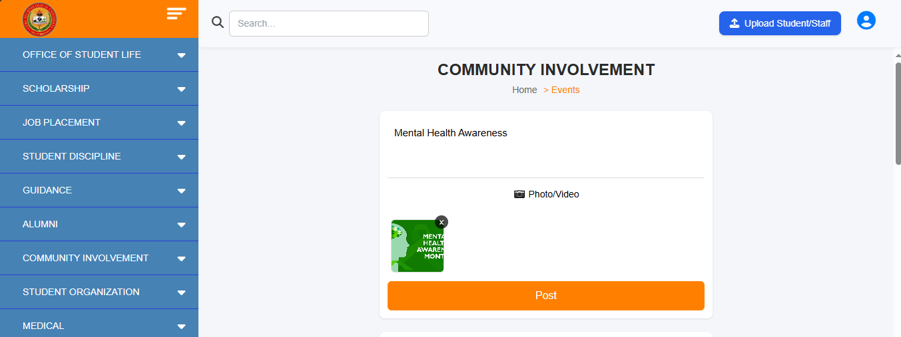

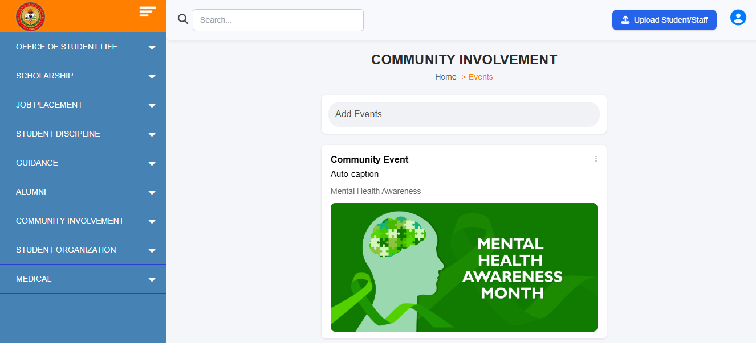



COLLEGE OF TECHNOLOGY AND ENGINEERING
Information Technology Department

USER ACCEPTANCE TESTING
Test Case ID | TC-Admin-0024
Capstone Project Title: | Student Affairs and Services System
Team | LOWCODE
 | Project Leader: | Honzel Babe Chavez
 |  | Kimberly Silvano
 | Front-End Programmer: | Jhudiel Anthony Carzano
 | QA Engineer: | Mharion Jay P. Sayson
 | Technical Writer: | Francis Xavier Sagarino
Title / Business Scenario | Verify that an authorized user can successfully create and publish a new Crowdfunding Project.
Preconditions | The user must be logged in as an authorized Admin or Staff member with posting privileges. The user must be on the Home → Crowdfunding page.
Test Data | Title: Project Library Renovation  Description: Seeking funds to upgrade old computers and furniture in the main campus library. Target: ₱50,000.  Image/Video: A valid image file (e.g., library_render.jpg)
Steps | 1. Go to the "CROWDFUNDING PROJECTS" page.
 | 2. Enter the Title (e.g., "Project Library Renovation").
 | 3. Enter the Description (e.g., "Seeking funds to upgrade...").
 | 4. Click "Photo/Video" and upload an image.
 | 5. Click the orange "Post" button.
Expected Result | The new project is successfully published and appears as the top item in the list of Crowdfunding Projects, complete with a title, description, image, and a functional Donate button.
Actual Result (Pass/Fail) | Pass
Comments / Attachments (Screenshots, Logs) | Screenshot attached to the next page
Tester Name / Date | Mharion Jay P. Sayson / 10/15/2025
Panelist's Remarks
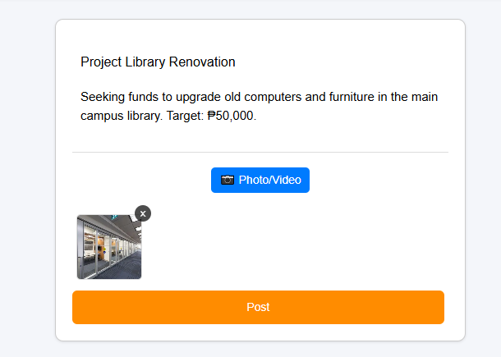
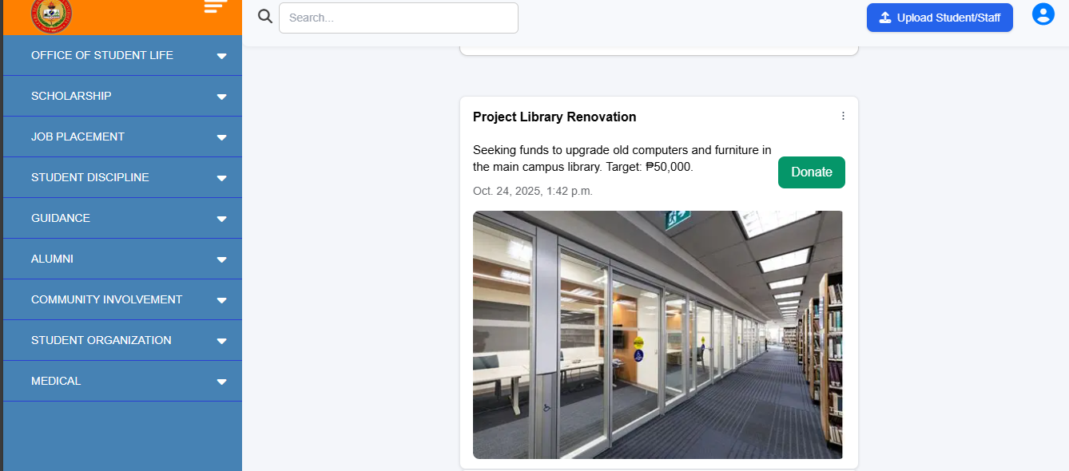



COLLEGE OF TECHNOLOGY AND ENGINEERING
Information Technology Department

USER ACCEPTANCE TESTING
Test Case ID | TC-Admin-0025
Capstone Project Title: | Student Affairs and Services System
Team | LOWCODE
 | Project Leader: | Honzel Babe Chavez
 |  | Kimberly Silvano
 | Front-End Programmer: | Jhudiel Anthony Carzano
 | QA Engineer: | Mharion Jay P. Sayson
 | Technical Writer: | Francis Xavier Sagarino
Title / Business Scenario | Verify that a general user (student/staff) can successfully initiate the donation process for a Crowdfunding Project.
Preconditions | The user must be logged in (or have access) as a potential donor (student/staff). A published project with a visible "Donate" button (like the one shown in the screenshot) must exist.
Test Data | Project Name: Project Library Renovation (from TC-UAT-0020, or the project labeled '5657')  Simulated Donation Amount: ₱500.00
Steps | 1. Go to the "CROWDFUNDING PROJECTS" page.
 | 2. Enter the Title (e.g., "Project Library Renovation").
 | 3. Enter the Description (e.g., "Seeking funds to upgrade...").
 | 4. Click "Photo/Video" and upload an image.
 | 5. Click the orange "Post" button.
Expected Result | The new project is successfully published and appears as the top item in the list of Crowdfunding Projects, complete with a title, description, image, and a functional Donate button.
Actual Result (Pass/Fail) | Pass
Comments / Attachments (Screenshots, Logs) | Screenshot attached to the next page
Tester Name / Date | Mharion Jay P. Sayson / 10/15/2025
Panelist's Remarks

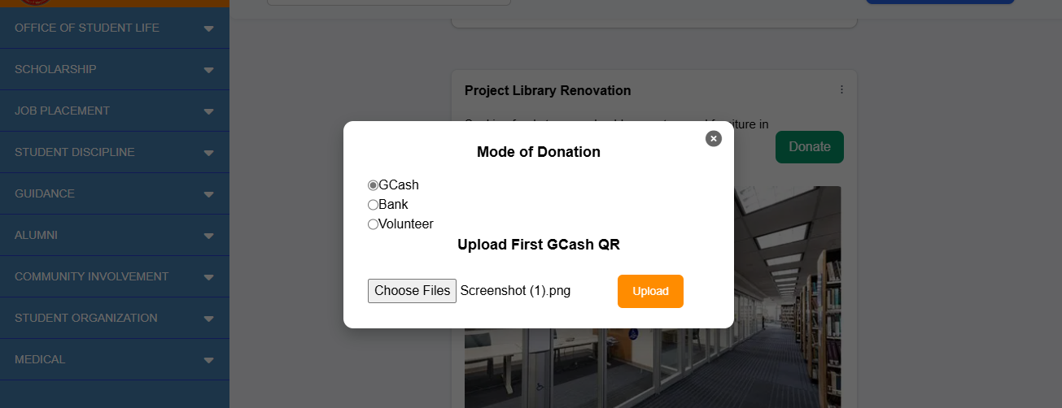



COLLEGE OF TECHNOLOGY AND ENGINEERING
Information Technology Department

USER ACCEPTANCE TESTING
Test Case ID | TC-Admin-0026
Capstone Project Title: | Student Affairs and Services System
Team | LOWCODE
 | Project Leader: | Honzel Babe Chavez
 |  | Kimberly Silvano
 | Front-End Programmer: | Jhudiel Anthony Carzano
 | QA Engineer: | Mharion Jay P. Sayson
 | Technical Writer: | Francis Xavier Sagarino
Title / Business Scenario | Verify that the Admin can successfully accept or decline a pending user donation and update its status.
Preconditions | The user must be logged in as an authorized Admin or Staff member. At least one donation must be in the "Pending" status on the "Donation Validate" page.
Test Data | Name: kimberly  Mode: GCash  Date: Oct. 24, 2025  Status: Pending
Steps | 1. Navigate to the "COMMUNITY INVOLVEMENT > Donation Validate" page.
 | 2. Locate a "Pending" donation record (e.g., the one from "kimberly").
 | 3. Click the "Accept" button under the "Options" column.
Expected Result | Clicking "Accept" sets the donation status to "Accepted" and marks the donation as valid in the system. Clicking "Decline" sets the status to "Declined" and invalidates the donation. The system should display a confirmation message after each action.
Actual Result (Pass/Fail) | Pass
Comments / Attachments (Screenshots, Logs) | Screenshot attached to the next page
Tester Name / Date | Mharion Jay P. Sayson / 10/15/2025
Panelist's Remarks
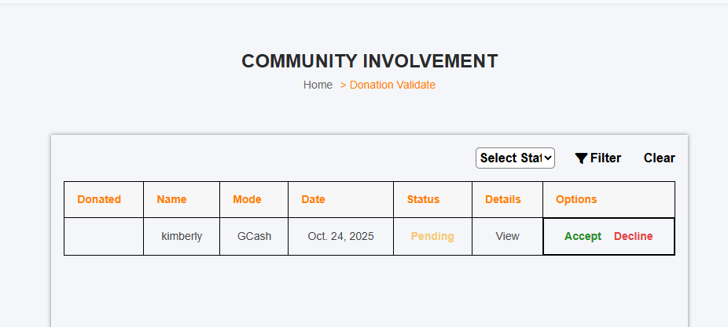



COLLEGE OF TECHNOLOGY AND ENGINEERING
Information Technology Department

USER ACCEPTANCE TESTING
Test Case ID | TC-Admin-0027
Capstone Project Title: | Student Affairs and Services System
Team | LOWCODE
 | Project Leader: | Honzel Babe Chavez
 |  | Kimberly Silvano
 | Front-End Programmer: | Jhudiel Anthony Carzano
 | QA Engineer: | Mharion Jay P. Sayson
 | Technical Writer: | Francis Xavier Sagarino
Title / Business Scenario | Verify that the Admin can successfully navigate to and view the list of donations and access the details of a specific donation.
Preconditions | The user must be logged in as an authorized Admin or Staff member. At least one donation must have been successfully recorded in the system (e.g., the entry shown in the screenshot).
Test Data | Donated: (Checkmark/Icon indicating donation)  Name : Kimberly Silvano  Amount: 500  Date: Sept. 20, 2025
Steps | 1. Navigate to the "COMMUNITY INVOLVEMENT > Select Donation" page.
 | 2. Verify that the donation list displays columns for "Donated," "Name," "Amount," and "Date."
 | 3. Locate a sample donation record.
 | 4. Click the "View" button under the "Details" column for that record.
Expected Result | The new project is successfully published and appears as the top item in the list of Crowdfunding Projects, complete with a title, description, image, and a functional Donate button.
Actual Result (Pass/Fail) | Pass
Comments / Attachments (Screenshots, Logs) | Screenshot attached to the next page
Tester Name / Date | Mharion Jay P. Sayson / 10/15/2025
Panelist's Remarks

